**Documentation on MongoDB basic commands**

**1.Run MongoDB**:

Go to the location where mongo DB is installed “C:\Users\isrp>” and open command prompt at that location and execute following command in command prompt.

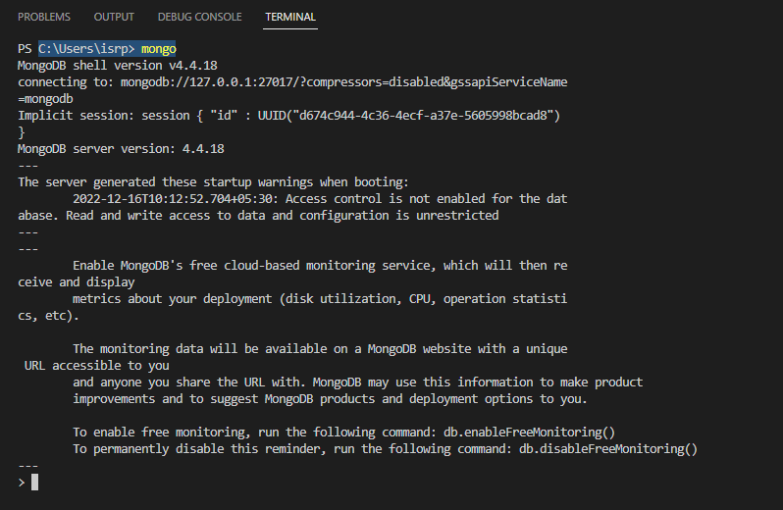

**2. Show all data bases:**

Use **show database** command to get list of all databases.

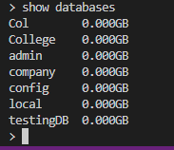

**3.Create new database:**

To create a new data database, execute the following command **use DATABASE_NAME.**



**4.To know your current selected database:**

To know your current working / selected database execute the following command **db.**



**5.Drop Database:**

To drop the database execute following command, this will drop the selected database

**db. dropDatabase ().**



**6.Create Collection:**

To create the new collection, execute the following command **db. createCollection(name).**

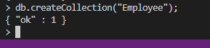

**7.To check collection list:**

To check the list of collection created execute the following command **Show collection.**



**8.Drop Collection:**

To drop the selected collection, execute the following command **db. COLLECTION_NAME.drop().**



**9.Insert document in collection:**

To insert single document in selected collection, execute the following command **>db.COLLECTION_NAME.insert(document).**

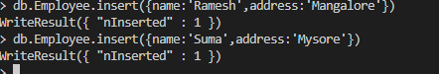

To insert multiple document in selected collection, execute the following command **>db.COLLECTION_NAME>insertMany(document).**

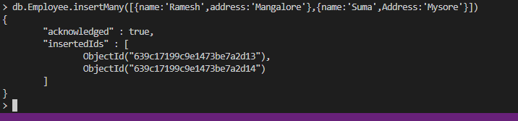

10.**Get collection document:**

**To get the list documents in collection execute the following command >db.COLLECTION_NAME.find().**

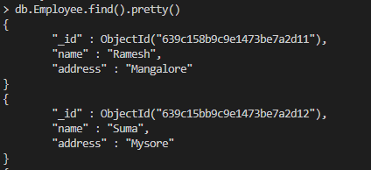

**11.Update document:**

To update the document in collection, execute the following command **>db.COLLECTION_NAME>update(SELECTION_CRITERIA.UPDATE_DATA).**

